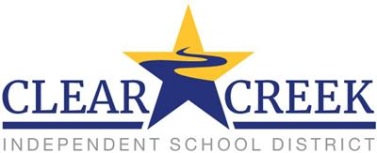

Special Services and SEPTA presents
Parent Resources Night

November 9th, 2017, 6:00-8:30 p.m.
Clear Springs High School - Cafeteria
Registration: http://tinyurl.com/CCISD-PRN-Nov-2017
Please register online by clicking the above hyperlink
This event is designed for families of children at any age and disability.

After the SEPTA business meeting a variety of presentations be offered at two separate times for parents to attend:

Setting up the Home for Success
Parent Friendly ABA Principles
Tools for Tackling Homework
Helping Parents Manage Behavior at Home
Fostering Independence
Building Social Circles and Social Safety

Child Care and Dinner Available- please register!!

